SCD Type 1

First create a warehouse in fabric.

In the lakehouse.
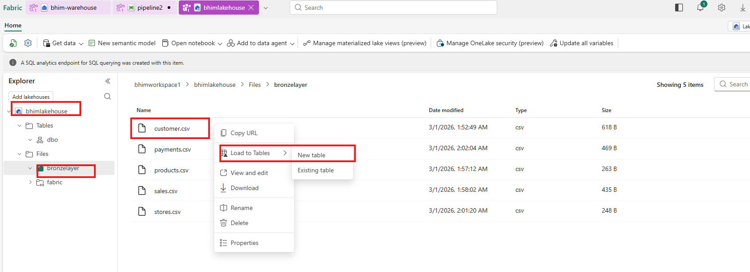

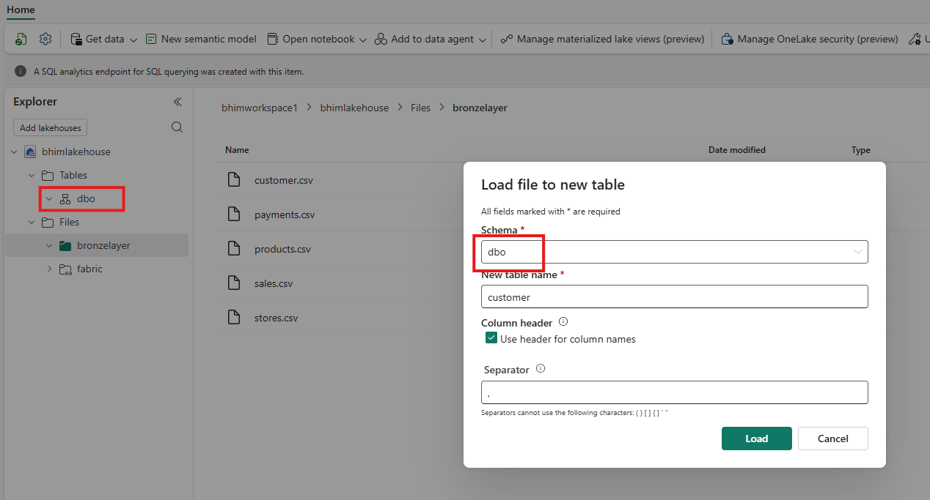
Now we have table in the lakehouse.
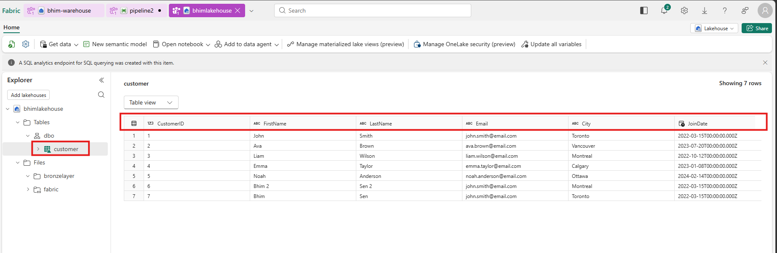

Go to warehouse.
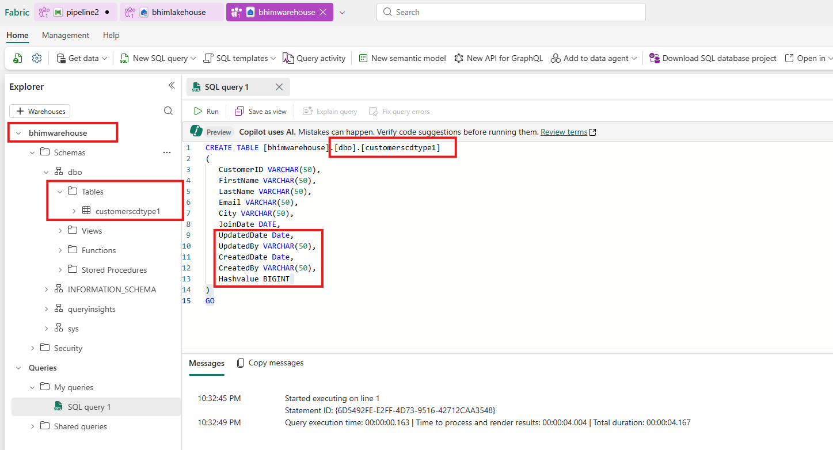

Create a stored procedure.
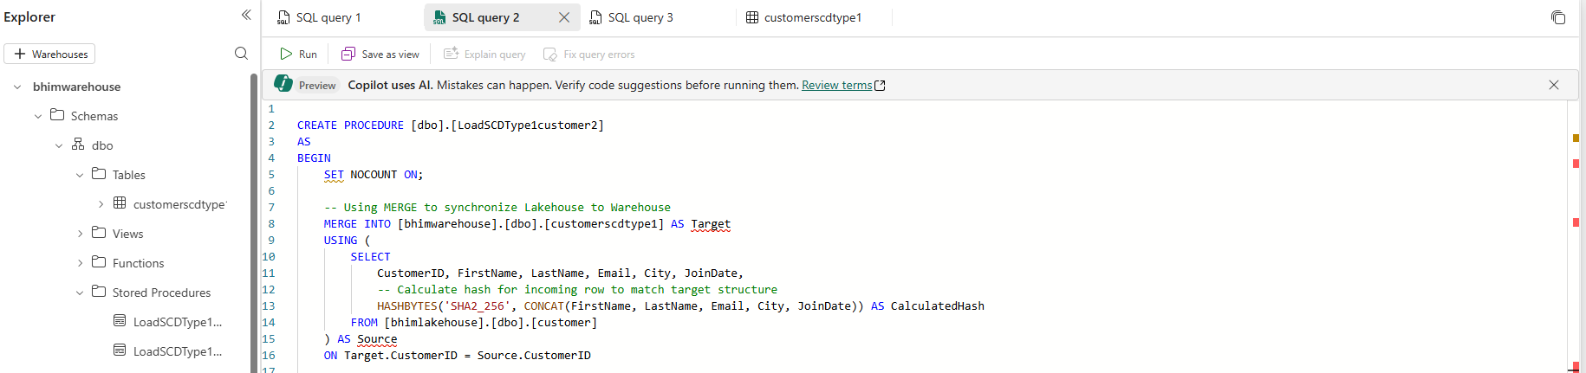
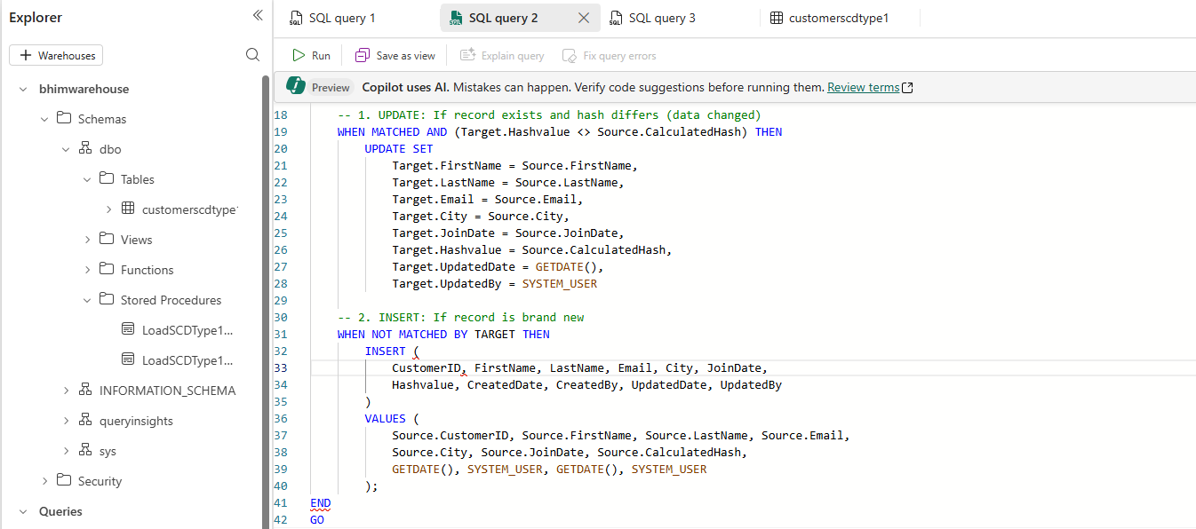
Exceute the Stored Procedure.
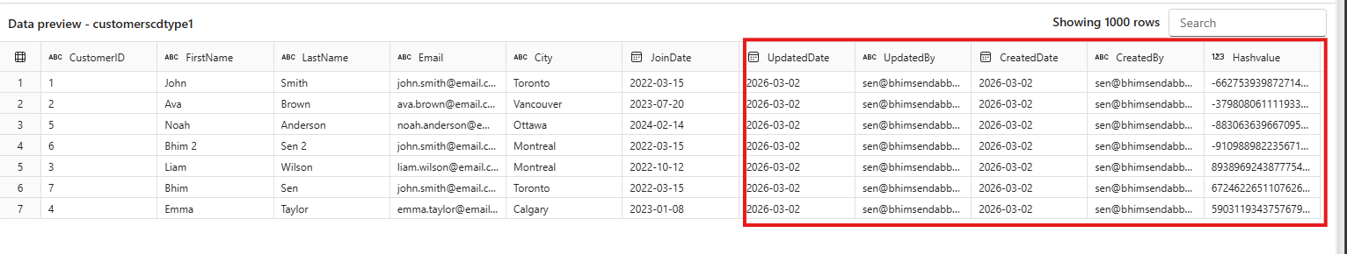
Now update the one record and insert one new record.
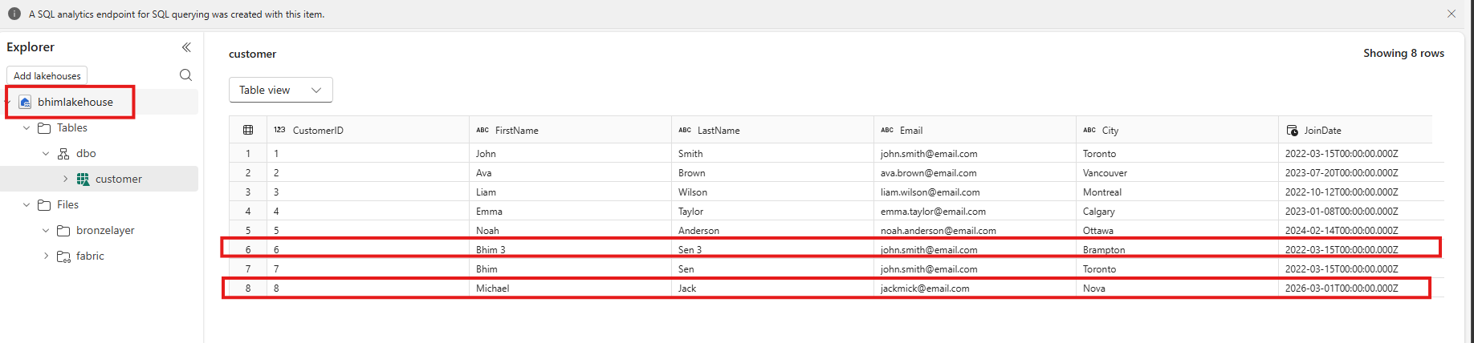
Run the stored procedure again.

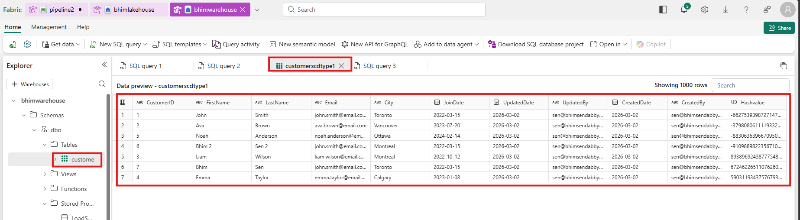

SCD TYPE 2

Lakehouse table
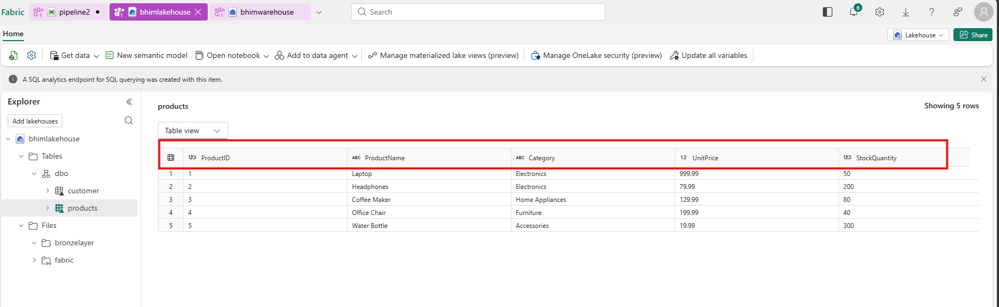
Creating table in warehouse
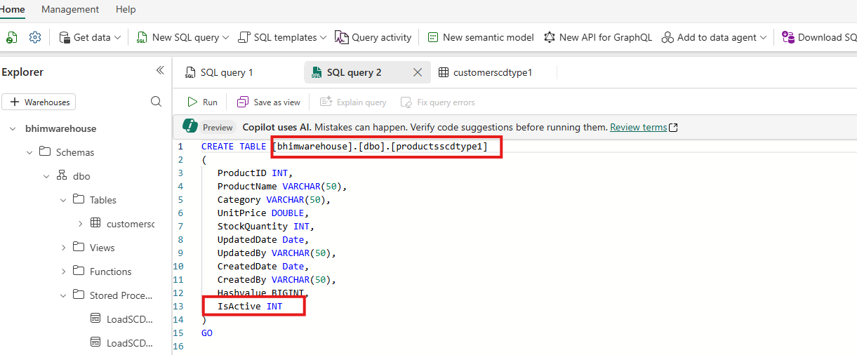Create Stored Procedure
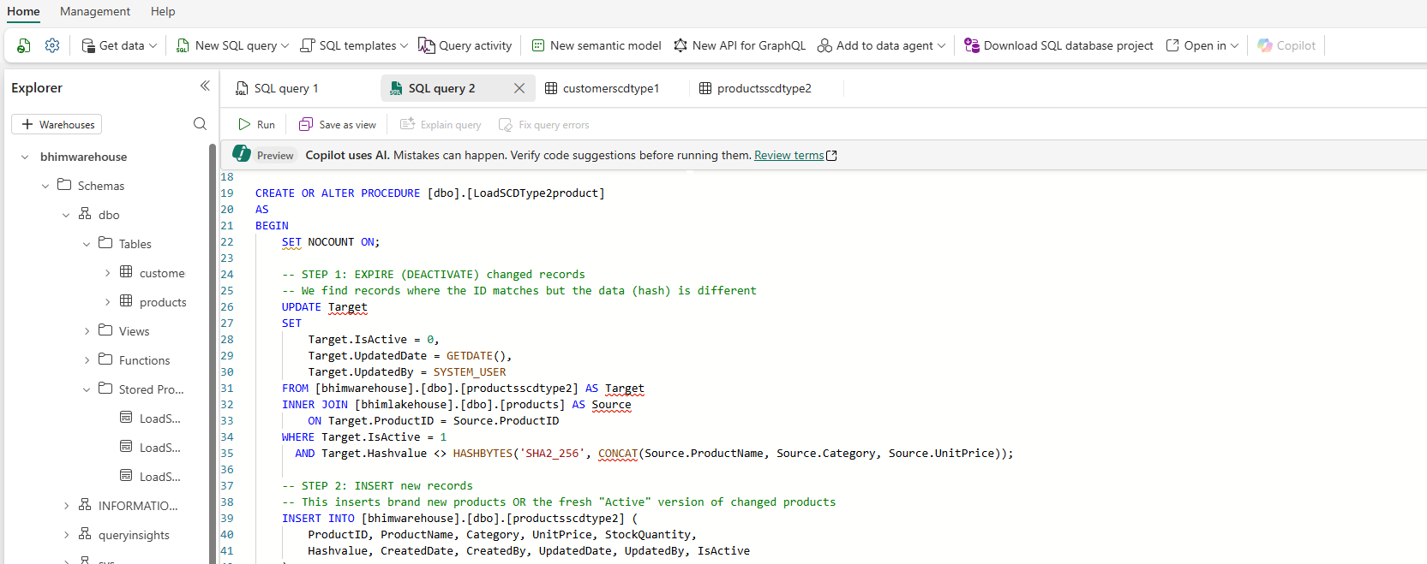
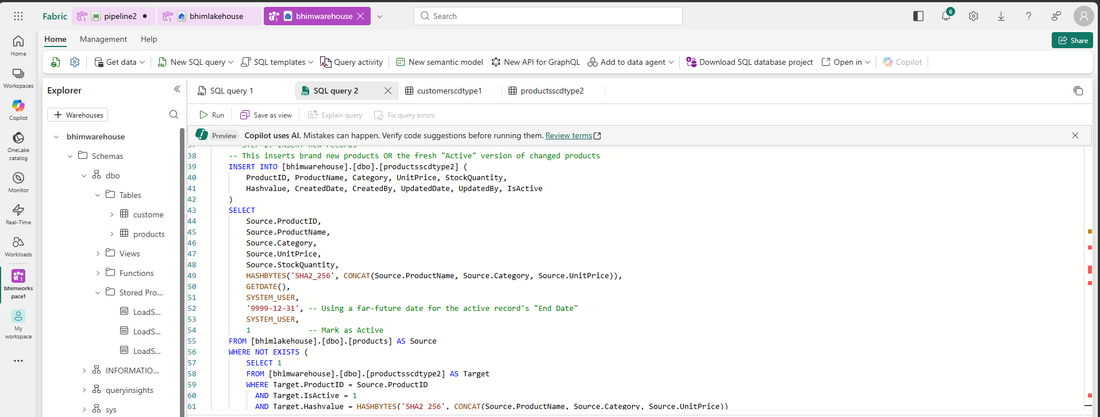
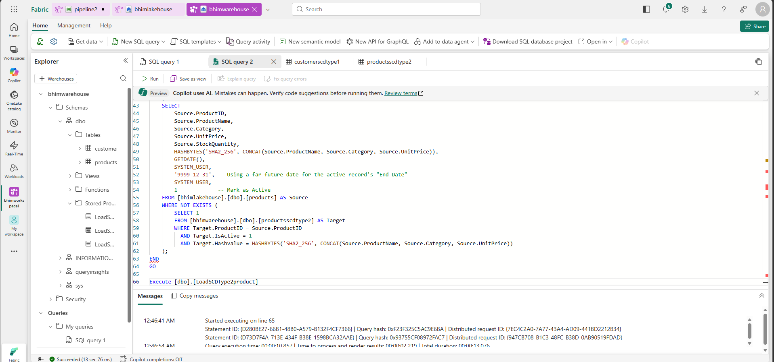
Exceute the procedure.
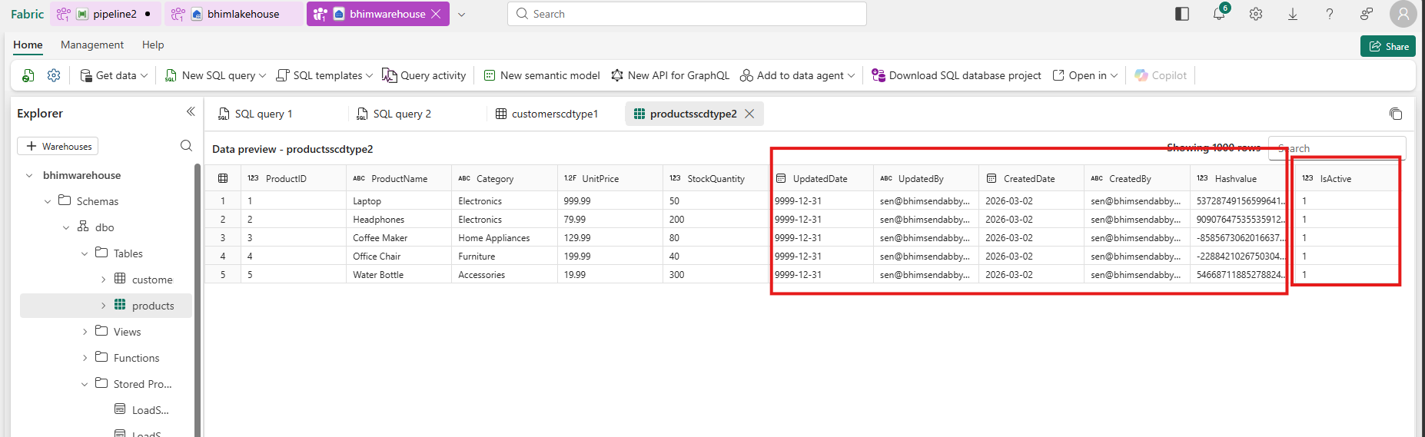

Update the record and insert new record in the products table in lakehouse.
